*CONTROL AND COORDINATION
NOTES
SOME IMPORTANT TERMS
Stimuli: The factors which bring response or change in the environment example Light, Heat, Cold, Sound, Smell, Touch etc.
Coordination: The working together of various organs of living organisms in a systematic, controlled way to produce a proper response to stimuli is known as coordination.
Hormones: These are chemical messengers which are secreted by endocrine glands. They coordinate the movements in plants.
Receptors: These are special tips of some nerve cells that detect information from the environment. These are located in our sense organs. Eyes, ear, skin ,nose and tongue.
Nervous System
It is the control system of the body.
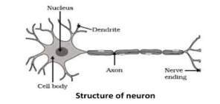
STRUCTURE OF NEURON
Cell body (cyton)- It is a broadly rounded part of the neuron that contains a central nucleus, cytoplasm, etc.
Dendrites- They are the branched process of the Cell body that receives and transmits stimulus.
Axon- It conducts impulses away from the cell body and it is the longest part of the neuron. It is covered with a protective sheath called the myelin sheath. Nerve ending- They are fine branches like the termination of neurons and transmit electrical impulses to another neuron.
FUNCTIONS OF NEURON
It regulates voluntary and involuntary movements of the human body It collects information from outside through sense organs and interprets it accordingly.
It helps in reasoning and thinking.
It controls reflex actions.
It enables us to remember things.
WORKING OF NEURON
The neuron receives information from receptors as an electrical impulse at the dendritic end.
This impulse travels from the dendrite to the cell body and then at the end of the axon.
There is a gap between two neurons called as (Synapse). These chemicals cross the gap and transfers the same signal to next neuron.
Chemical are released at the end of the axon by the effect of electrical impulse. NERVOUS SYSTEM
CENTRAL NERVOUS SYSTEM (CNS) {Human Brain & Spinal Cord}
PERIPHERAL NERVOUS SYSTEM (PNS) {3 types of Nerves}
Central Nervous System (CNS)
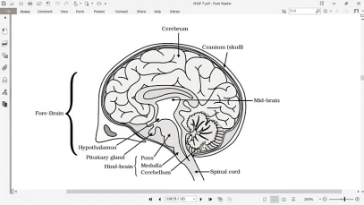HUMAN BRAIN It is the main coordinative center of the body which enables an organism to think and take action.
Three Regions of Brain:
1. Fore Brain
2. Mid Brain
3. Hind Brain
Forebrain- It is the largest and main thinking part of the brain which receives sensory impulses. Parts of Forebrain are:
Cerebrum- It is dome-shaped, and considered as a roof of the brain. It acts as the main thinking part of the brain. It is responsible for reasoning, speech, and the usage of information.
Lobes
Frontal- controls voluntary movements of muscles, memory, and speech. Parietal- a sense of touch and taste.
Temporal- a sense of smell and hearing.
Occipital- a sense of vision.
Mid Brain- It is composed of the hypothalamus.
Hypothalamus
It lies at the base of the cerebrum.
It also controls the urges for eating and drinking.
It controls sleep and wake cycle of the body.
Hindbrain- It provides a connection b/w the spinal cord and the rest of the brain. It is composed of three parts:
Cerebellum
It lies below cerebrum
It coordinates the motor functions.
It controls posture and balance.
It controls voluntary activities.
Medulla
If forms the brain stem.
It lies at the base of the brain & continues into the Spinal Cord.
It controls involuntary functions like hearing, heart beating and
Respiration, salivation, vomiting.
Pons
It also controls involuntary actions
It regulates respiration
SPINAL CORD
It is a long, cylindrical like structure.
It controls reflex actions and is enclosed in a long cage called the vertebral column.
Peripheral Nervous System
3 TYPES OF NERVES:
Cranial nerves- emerge from the brain and spread throughout the head. Spinal nerves- emerge from the spinal cord and spread throughout the body (except the head).
Visceral nerves- emerge from the spinal cord and are connected to internal organs
REFLEX ACTION: It is quick, sudden and immediate response of the body to a stimulus. Eg – Knee jerk, withdrawal of hand on touching an object.
REFLEX ARC: The pathway taken by nerve impulses in a reflex action is called a reflex arc.
HEAT --> RECEPTORS --> SPINAL ORGAN --> EFFECTOR ORGAN --> RESPONSE (Stimulus). (skin) (Muscles) (Hand Withdraw)
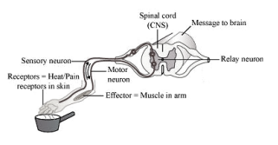
THREE TYPES OF RESPONSES:
Voluntary: Controlled by forebrain. Example – talking, writing etc.
Involuntary: Controlled by mid & hind brain. Example – heat beat, vomiting, respiration.
Reflex action: Controlled by spinal cord. Example – withdrawal of hand on touching hot object.
IMPORTANCE OF REFLEX ACTION
It enables organisms for immediate response to a stimulus.
It reduces the overloading of the brain.
It increases the chances of survival of an organism.
L.P. : How do we detect the smell of agarbatti?
We can detect the smell of agarbatti by olfactory lobes present in the forebrain. The smell reaches the neurons by olfactory receptors of the nose and causes the generation of impulses to the CNS for ultimate response.
L.P. :“Reflex arcs continue to be more efficient for quick responses”. Justify this statement giving reason.
Reflex action is an automatic and spontaneous response to a stimulus. The pathway taken by nerve impulses and responses in a reflex action is called a reflex arc. It consists of receptor, sensory nerve (afferent), spinal cord, motor nerve (efferent) and effector (muscles or glands). Reflex arc is evolved in animals because the thinking process of the brain is not fast enough. Reflex arc enables the body to give quick responses to harmful stimuli so that chances of damage to body are decreased. It also prevents overloading of brain, so prevents its fatigue. Many animals have very little or none of the complex neuron network needed for thinking. So, it is likely that reflex arc has evolved as an efficient way of functioning in the absence of true thought processes. However, even after complex neuron networks have came into existence, reflex arcs continue to be more efficient for quick responses.
Coordination in PLANTS
The plants do not have a nervous system and sense organs like eyes, ears, or nose, etc., like the animals, but they can still sense things.
The plants coordinate their behaviour against environmental changes by using hormones.
There are four major types of plant hormones (or phytohormones) which are involved in the control and coordination in plants :
Auxin
It is a hormone that is synthesized in the young shoot tip to promote fruit and shoot growth.
When light is coming from one side, it is diffused towards the dark side of the shoot which stimulates the cells to grow longer, resulting in the bending of the shoot towards the light.
Auxins promote cell enlargement and cell differentiation in plants.
Gibberellins
Gibberellins are plant hormones which promote cell enlargement and cell differentiation in the presence of auxins.
Gibberellins help in breaking the dormancy in seeds and buds. They also promote growth in fruits.
Gibberellin hormone is involved mainly in shoot extensions. Gibberellin stimulate elongation of shoots of various plants.
Cytokinin’s
Cytokinin’s are the plant hormones which promote cell division in plants. Cytokinin’s also help in breaking the dormancy of seeds and buds. They delay the ageing in leaves.
Cytokinin’s promote the opening of stomata. They also promote fruit growth. Abscisic acid
It is a growth-inhibition hormone.
It helps in stomatal closure and causes dormancy of seeds, loss of protein, and chlorophyll.
It promotes the falling of leaves.
TROPISMS (OR TROPIC MOVEMENTS)
Plants do not have a nervous system instead they show movement and response. The ability of plants to detect change and respond to the same is termed the sensitivity of plants.
The movement of plants in direction of stimulus is known as tropism. Tropic Movement- When the stimulus has a particular direction and the movement of the plant occurs in direction of the same, the movement is called tropic movement.
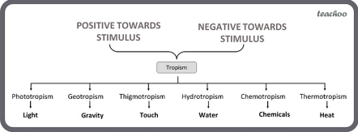
If the growth (or movement) of a plant part is towards the stimulus, it is called positive tropism.
If the growth (or movement) of a plant part is away from the stimulus, then it is called negative tropism.
TYPES OF TROPIC MOVEMENT/TROPISM:
Phototropic movements- The movement of plant parts in response to light is called phototropic movement. The phenomenon is called phototropism. For Example: The stem (or shoot) of a growing plant bends towards light, so the stem (or shoot) of a plant shows positive phototropism. On the other hand, the roots of a plant move away from light, so the roots of a plant show negative phototropism.
Geotropism: The movement of a plant part in response to gravity is called geotropism. For Example: If the plant part moves in the direction of gravity, it is called positive geotropism. On the other hand, if the plant part moves against the direction of gravity, it is negative geotropism.
Thigmotropism: The directional growth movement of a plant part in response to the touch of an object is called thigmotropism.
Hydrotropism: The movement of a plant part in response to water is called hydrotropism. For Example: If the plant part moves towards water, it is called positive hydrotropism. If the plant part moves away from water, then it is called negative hydrotropism.
Chemotropism: The movement of a plant part in response to a chemical stimulus is called chemotropism. For example: If the plant part shows plant part shows movement (or growth) towards the chemical, it is called positive chemotropism. If the plant part shows movement (or growth) away from the chemical, then it is called negative chemotropism.
NASTIC MOVEMENTS/NASTIES:
The movement of a plant part in response to an external stimulus in which the direction of response is not determined by the direction of stimulus is called nastic movement.
The folding up of the leaves of a sensitive plant (Mimosa pudica) on touching is an example of nastic movement. Here the stimulus is touch.
TYPES:
Photonasty (stimulus-light) Eg- opening, and closing of petals of oxalis. Thigmonasty (stimulus- contact of insect) Eg- bending of tentacles. Thermonasty (stimulus- change in temp) Eg- opening and closing of tulip flower
Seismonasty (stimulus-touch)Eg- dropping of leaves in touch-me-not plant. Hormones in Animals
GLANDS: A gland is a structure which secretes a specific substance (or substances) in the body. A gland is made up of a group of cells or tissue. There are two types of glands in the body:
1.
2.
Exocrine glands Endocrine glands
ENDOCRINE GLANDS:
They are the chemical messengers that are secreted in small quantities. There are two types of glands- endocrine glands and exocrine glands. Endocrine glands do not have ducts to carry the secretion and they produces the hormones.
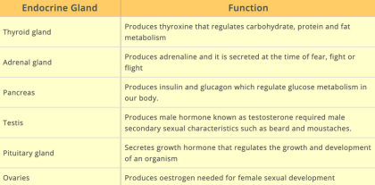
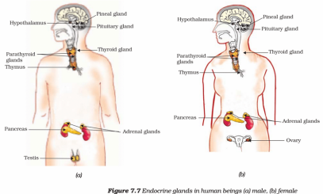
Kuch Kaam Ki Baat (K B) :
3
LP: Why is it advised to use iodised salt in our diet ?
Iodine stimulates the thyroid gland to produce thyroxin hormone. Deficiency of this hormone results in the enlargement of the thyroid gland. This can lead to goitre.
Feedback Mechanism- The timing and amount of hormone released in our body is controlled by a mechanism called the feedback mechanism. It keeps the secretion of hormones from glands in appropriate quantity. Eg- if sugar levels in the blood rise, the insulin hormone is secreted by the pancreas and if it falls then glycogen is broken down.
How does our body respond when adrenaline is secreted into the blood? It is secreted by the adrenal gland. At the time of emergency or stress, it is released in large quantities. As a result, the heartbeat increases which result in more supply of oxygen in muscles. All these responses together help the animal to deal with an emergency.
Hormonal Disorders- All hormones secreted in our body are required in the appropriate amount. Slightly more or less can lead to diff disorders. Eg
1.
Dwarfism- Growth hormone is responsible for regular growth and development of the body. A deficiency of this leads to dwarfism.
2.
Gigantism- Excess secretion of growth hormone leads to an abnormal condition known as gigantism.
3.
Goiter- Iodine is essential for releasing thyroxine hormone. In case, iodine is deficient in the body, there occurs the possibility of goiter. One of the major symptoms is a swollen neck.
4.
Diabetes- It occurs when less amount of insulin is secreted by the pancreas. In this condition, sugar is accumulated in the body causing harmful effects.
-- PREVIOUS YEAR QUESTIONS --
1 MARK QUESTIONS (INCLUDING MCQs)
Q1. How is the spinal cord protected in the human body? [CBSE 2010]
Ans 1. A protective layer of bone called the vertebral column covers and protects your spinal cord.
Q2. Which organ secretes a hormone when the blood sugar rises? Name a digestive enzyme released by this organ.
[CBSE Sample Paper, 2008]
Ans 2. Pancreas secrete insulin when the blood sugar rises. It also produces the enzyme trypsin in an inactive form called trypsinogen.
Q3. What does the given experimental set-up demonstrate? [CBSE Sample Paper, 2008] 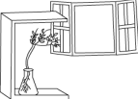
Ans 3. The above experimental setup is used to determine the response of plant parts towards sunlight. The bending of shoot in the direction of sunlight is termed as phototropism.
Q4. A particular hormone requires iodine for its synthesis. Name the endocrine gland which secretes this hormone and state its location in the human body. [CBSE Sample Paper, 2008] Ans 4. Thyroxine is the hormone that needs iodine for its synthesis. It is produced by thyroid gland that is situated close to the trachea in the neck. It regulates carbohydrate, fat, and protein metabolism in our body.
Q5. Name any two types of tropism. [CBSE Sample Paper, 2010]
Ans 5. phototropism (response to light), geotropism (response to gravity)
2 MARKS QUESTIONS
Q6. What are hormones? Name the hormone secreted by thyroid and state its function. [CBSE 2010]
Ans 6. Hormones are chemical messengers which are directly secreted into blood by ductless glands also known as endocrine gland and act on different distant organs. Thyroxine is the hormone secreted by the thyroid gland. This hormone regulates the metabolism of carbohydrates, fats and proteins. By regulating the metabolism it helps in optimum growth and development of the body.
Q7. I. Label the two parts indicated by question marks and labelled 1 and 2 in the diagram. II. Suggest a suitable caption or heading for the diagram.
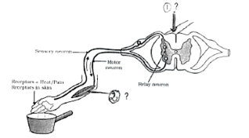 [CBSE Sample Paper, 2008] Ans 7. (a) Label 1: Central canal (or spinal cord if pointing to the outward region). Label 2: Effector muscle (where the motor nerve fibres relay or send some particular electrical impulses or messages to the motor impulses from the CNS or central nervous system to the Effector organs, making a reaction towards the stimuli).
(b) Reflex Action or Reflex arc
Q8. The given experimental set up tests the response of different parts of plant towards gravity. Use scientific terms for the conclusions.
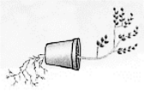 [CBSE Sample Paper, 2008]
Ans 8. The response of shoot to sunlight i.e. bending of shoot in the direction of sunlight is called phototropism.
The response of root to gravity i.e. growth of roots in the downward direction is called geotropism.
3 MARKS QUESTIONS
Q9. What is 'phototropism'? How does it occur in plants? Describe an activity to demonstrate phototropism. [CBSE 2009]
Ans 9. Phototropism: Phototropism is the directional response of a plant that allows the plant to grow towards or in some cases away from the light.

Process of phototropism:
1. Leaf tips and stem tips have a hormone called auxin which is sensitive to light. 2. It allows the plant to positively grow towards the light source.
3. This is called positive phototropism.
4. In case the plant grows away from the light source, it is known as negative phototropism. This is usually shown by roots.
Example of plant that shows phototropism: Sunflower

Activity: To demonstrate it we will place a potted plant in a box in which light. comes from only one direction. in a few days, we will observe that the shoot has moved towards the side from which light came in the box.

Q10. Label parts 1 to 6 in the given figure of the brain
[CBSE Sample Paper, 2008]
Ans 10. 1) Cerebrum 2) Mid-brain 3) Cerebellum 4) Medulla 5) Pons 6) Hypothalamus.
5 MARKS QUESTIONS
Q11. A) Draw the structure of a neuron and label the following on it: [CBSE 2008] Nucleus, Dendrite, Cell body and Axon
B) Name the part of neuron:
I. where information is acquired.
II. through which information travels as an electrical impulse.

(b) (i) Dendrites acquire stimulus or information from the other cells.
(ii) Axon carries away information from the cell body to the dendrite of the next neuron.
Q12. A) Draw a neat diagram of human brain and [CBSE Sample Paper, 2017] I. Label Medulla and Cerebellum
II. Write the functions of the above mentioned parts
B) "Both overproduction and underproduction of Growth hormone leads to disorders in the body." Explain.

Function of cerebellum − It helps to maintain posture, equilibrium, and coordination in voluntary movements.
Function of medulla −It helps to control our involuntary muscles such as cardiac, respiratory, etc. It controls the activities of internal organs
(b) Growth hormones are required for the proper development of the body. Oversecretion or under secretion of this hormone can lead to various types of abnormalities.
The two abnormalities associated with growth hormone are dwarfism and gigantism. Dwarfism is caused when the growth hormone is not secreted in the required amount whereas the over secretion of the growth hormone results in gigantism.

